ACTIVITY 4: - STATISTICS

* **MODEL:**  YEARS TO GRADUATE IS **7**
* TOTAL NUMBER OF STUDENTS: **1000**
* YEARS TAKEN TO GRADUATE:

|  |  |  |  |  |  |  |  |
| --- | --- | --- | --- | --- | --- | --- | --- |
| **3** | **4** | **5** | **6** | **7** | **8** | **9** | **10** |

* **STUDENTS GRADUATED: -**

|  |  |  |  |  |  |  |  |
| --- | --- | --- | --- | --- | --- | --- | --- |
| **112** | **327** | **258** | **164** | **70** | **49** | **18** | **2** |

HERE X : YEARS TAKEN TO GRADUATE LIKE (3,4,5….10)

* **PROBABILITY CALCULATIONS: -**
* P(X=3) = 112/1000 = 0.112
* P(X=4) = 327/1000 = 0.327
* P(X=5) = 112/1000 = 0.258
* P(X=6) = 112/1000 = 0.164
* P(X=7) = 112/1000 = 0.070
* P(X=8) = 112/1000 = 0.049
* P(X=9) = 112/1000 = 0.018
* P(X=10) = 112/1000 = 0.002

|  |  |
| --- | --- |
| **X (YEARS TAKEN)** | **P(X=x)** |
| **3** | **0.112** |
| **4** | **0.327** |
| **5** | **0.258** |
| **6** | **0.164** |
| **7** | **0.070** |
| **8** | **0.049** |
| **9** | **0.018** |
| **10** | **0.002** |

* **A BINOMIAL DISTRIBUTION MADE BY ANALYSIS OF THE DATA: -**
* Let's "success" be an event as a student took exactly 7 years for graduation.
* All other years (3,4,5,6,8,9,10) will be considered as a "failure”.
* Number of Trials (n) = n = 10
* Probability of Success (p) = 0.070
* Probability of Failure (q): q = 1-p = 0.93
* **CALCULATING PROBABILITIES: -**
* Parameters
* Number of Trials (n): 10
* Probability of Success (p): 0.070
* Probability of Failure (q): q= 1-p= 0.93, q = 1-p = 0.93, q= 1-p = 0.93
* K = 0 to k = 10

| **k (Number of Students Taking Exactly 7 Years)** | **P (X = k)** |
| --- | --- |
| **0** | **0.263** |
| **1** | **0.357** |
| **2** | **0.247** |
| **3** | **0.095** |
| **4** | **0.024** |
| **5** | **0.004** |
| **6** | **0.0006** |
| **7** | **0.00006** |
| **8** | **0.000004** |
| **9** | **0.0000003** |
| **10** | **0.00000001** |

**GRAPHS FOR BINOMIAL DISTRIBUTION**

Steps:

1. Binomial Distribution (Theoretical): Use the probabilities calculated earlier for the number of Years taken is exactly 7 in sample of 10 students
2. Experimental Distribution: Assume we have an experimental distribution based on the number of Years taken is exactly 7, derived from actual observation.

**EXAMPLE EXPERIMENTAL DISTRIBUTION PARAMETERS**

Number of Trials (n): 10

Probability of Success (p): Approximately 0.3

Probability of Failure (q): q = 1-p ≈ 0.7 (approx. 0.7)

|  |  |
| --- | --- |
| **k (Number of Students Taking Exactly 7 Years)** | **P (X = k)** |
| **0** | **0.2503** |
| **1** | **0.3249** |
| **2** | **0.2384** |
| **3** | **0.1151** |
| **4** | **0.0177** |
| **5** | **0.0000** |
| **6** | **0.0295** |
| **7** | **0.0141** |
| **8** | **0.0000** |
| **9** | **0.0100** |
| **10** | **0.0000** |

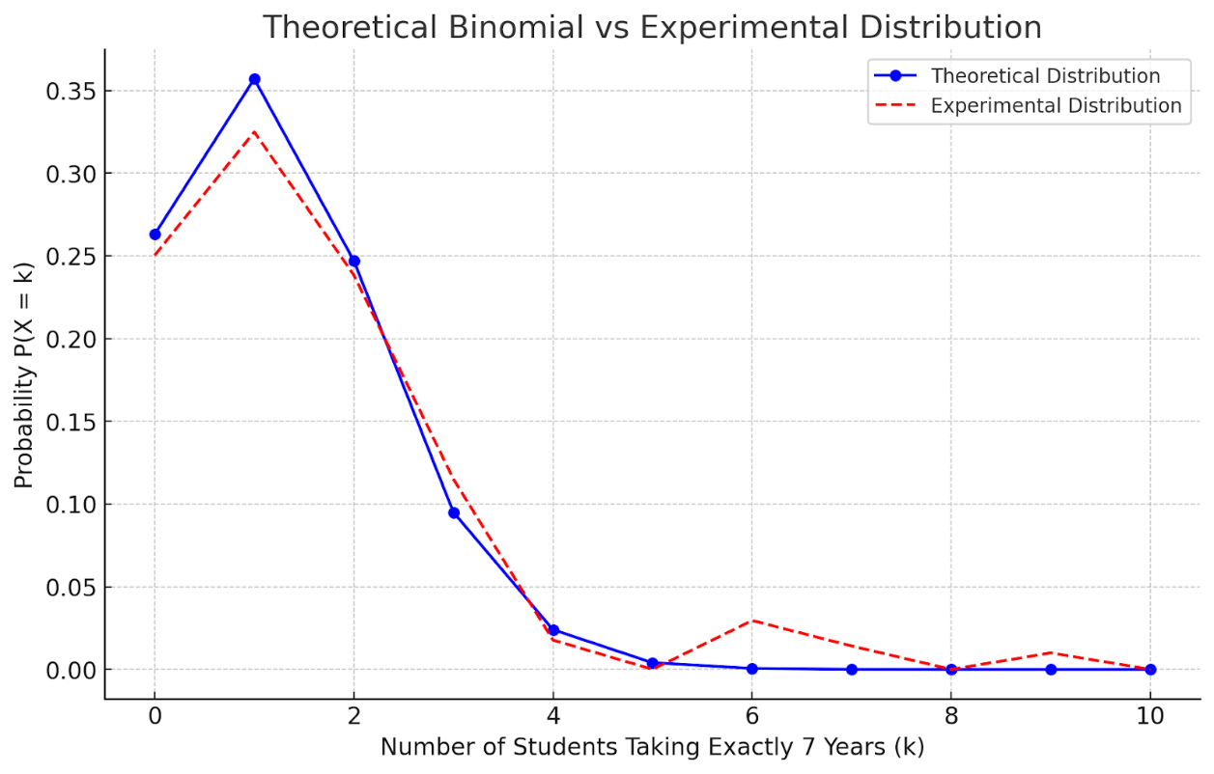

**GRAPH OF THEORETICAL BINOMIAL AND EXPERIMENTAL DISTRIBUTIONS**